COMMON COURSE ASSIGNMENT FORMAT

Assignment Information

Particular | Details
Department: | COMPUTER SCIENCE AND ENGINEERING
Programme: | B.E CSE
Course Code & Course Name | CSA15-CLOUD COMPUTING AND BIG DATA ANALYSIS
Academic Year / Batch | CSE-AI
Faculty Name | Dr.J.CHENNI KUMARAN
Assignment Title | Smart-City Traffic and Transportation Analytics Using Big Data Technologies
Date of Issue | 01/09/2026
Date of Submission | 02/09/2026
Maximum Marks | 100
Course Outcome(s) – CO | CO1: Apply Big Data concepts and distributed processing techniques to solve real-world traffic and transportation analytics problems.  CO2: Design and implement a Hadoop-based Big Data processing system using HDFS, MapReduce, and YARN for storing and analysing large-scale transportation datasets.  CO3: Analyse traffic patterns, congestion levels, vehicle movement, and transportation trends using distributed data processing and interpret the results for sustainable smart-city planning.
Bloom's Taxonomy Level | L3 – Apply, L4 – Analyze,
SDG Mapping (SDG 1-17) | • SDG 9 – Industry, Innovation and Infrastructure • SDG 11 – Sustainable Cities and Communities • SDG 12 – Responsible Consumption and Production • SDG 13 – Climate Action
Industry / Societal Relevance | Smart transportation, traffic management, congestion reduction, road safety, sustainable urban development

Assignment Problem / Challenge
Modern cities generate large volumes of transportation data from traffic sensors, GPS devices, cameras, road networks, public transportation systems and mobile applications. Processing such data using conventional techniques can become difficult because of its volume, velocity and variety.
The challenge is to develop a Smart-City Traffic and Transportation Analytics system using Big Data technologies. The system should process traffic data, perform preprocessing, identify traffic patterns, analyze congestion and generate useful visualizations for transportation decision-making.
The assignment requires students to:
- Apply Big Data and Data Mining concepts.
- Perform data cleaning and preprocessing.
- Process transportation data using PySpark.
- Analyze traffic volume and average speed.
- Identify peak traffic hours.
- Identify locations with higher congestion.
- Apply clustering to identify different traffic patterns.
- Visualize the results using Python.
- Provide recommendations for smart-city traffic management.

Problem Statement

Problem / Case / Design Challenge:

A smart city continuously collects traffic information such as:
- Timestamp
- Road/location
- Number of vehicles
- Average vehicle speed
- Road capacity
- Congestion level
The objective is to develop a Big Data analytics system that can process these records and identify:
- Peak traffic hours.
- High-traffic road locations.
- Average vehicle speed variations.
- Congestion levels.
- Different traffic patterns using clustering.
- Useful recommendations for traffic management.
The proposed system will be implemented using Google Colab,

Requirements and Constraints
Functional Requirements
- Load traffic data into the system.
- Remove duplicate records.
- Handle missing values.
- Validate traffic-related numerical values.
- Extract time-related features.
- Calculate congestion ratio.
- Analyze traffic by hour and location.
- Perform traffic-pattern clustering.
- Generate graphs and analytical results.
Technical Requirements
- Google Colab
- Python
- PySpark
- Spark SQL
- Pandas
- NumPy
- Matplotlib
- Scikit-learn/PySpark ML where required
Constraints
- The implementation should run in Google Colab.
- The system should use free/open-source tools.
- Data should be anonymized or aggregated.
- Invalid and missing records should be handled.
- The solution should be scalable for larger datasets.
- Results should be presented using tables and graphs.

Student Work
1. Problem Understanding and Formulation
What is the problem?
The problem is to analyze large-scale traffic and transportation data to identify congestion patterns, traffic peaks and road-level transportation conditions.
Expected Outcomes
The proposed system should produce:
- Cleaned traffic dataset.
- Traffic statistics.
- Peak-hour analysis.
- Location-wise traffic analysis.
- Congestion analysis.
- Traffic clusters.
- Graphical visualizations.
- Smart-city traffic management recommendations.
Available Data
The dataset can contain:

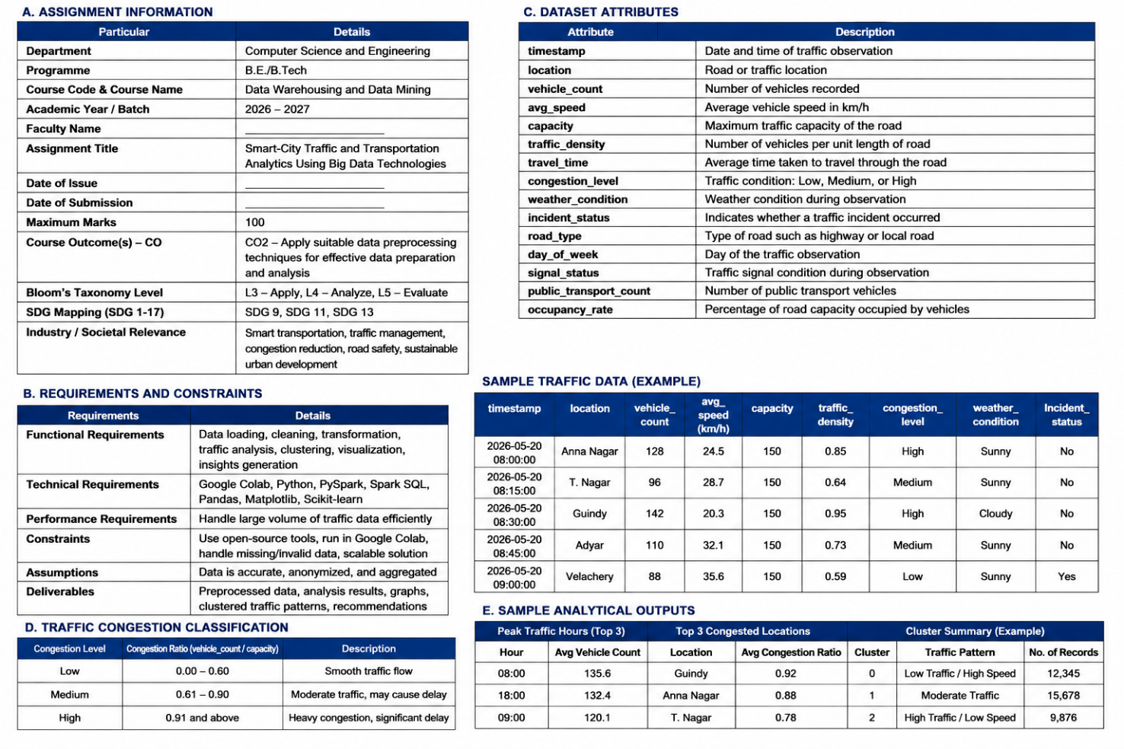
Assumptions
- Traffic records contain valid timestamps.
- Vehicle count is non-negative.
- Speed values are positive.
- Road capacity is greater than zero.
- Location names are consistently represented.
- Data is used for aggregated traffic analysis.
2. Application of Course Knowledge
The following Data Warehousing, Data Mining and Big Data concepts are applied:
Big Data Concepts
- Volume
- Velocity
- Variety
- Veracity
- Distributed processing
Data Preprocessing
- Data cleaning
- Duplicate removal
- Missing-value handling
- Data type conversion
- Data validation
- Feature engineering
Data Mining
- Descriptive analytics
- Aggregation
- Correlation analysis
- K-Means clustering
- Pattern identification
Big Data Technology
Apache Spark / PySpark is used to process the traffic data using distributed DataFrame operations.
3. Solution / Design / Methodology
Proposed Methodology
The system follows the following pipeline:
Traffic Data
↓
Data Collection
↓
Data Cleaning
↓
Data Transformation
↓
PySpark DataFrame
↓
Spark SQL / Aggregation
↓
Traffic & Congestion Analysis
↓
K-Means Clustering
↓
Visualization
↓
Smart-City Traffic Recommendations

Module 1 – Data Collection and Preprocessing
- Create or upload traffic dataset.
- Load data into PySpark.
- Inspect schema.
- Remove duplicates.
- Handle missing values.
- Remove invalid traffic values.
- Convert columns into suitable data types.

Module 2 – Big Data Traffic Analytics
- Extract hour from timestamp.
- Calculate congestion ratio.
- Analyze traffic volume.
- Calculate average speed.
- Perform location-wise analysis.
- Identify peak traffic periods.
Module 3 – Traffic Pattern Mining and Visualization
- Apply K-Means clustering.
- Identify traffic groups.
- Analyze cluster characteristics.
- Generate traffic graphs.
- Interpret results.
- Provide smart-city recommendations.

4. Use of Modern Tools



5. Results and Validation
The system should generate:
Result 1 – Dataset Information
Display:
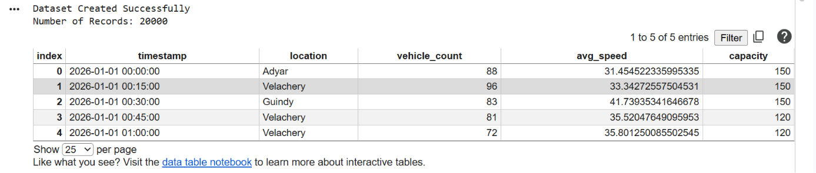
Result 2 – Peak Traffic Analysis
Identify the hours having the highest average vehicle count.
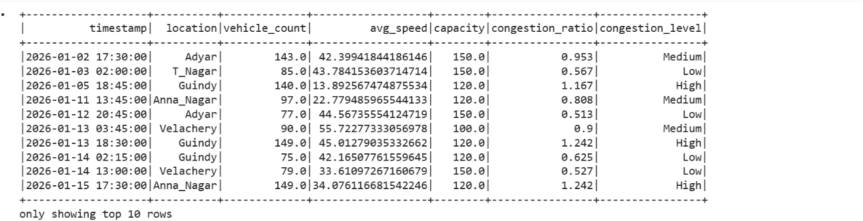
Result 3 – Location Analysis
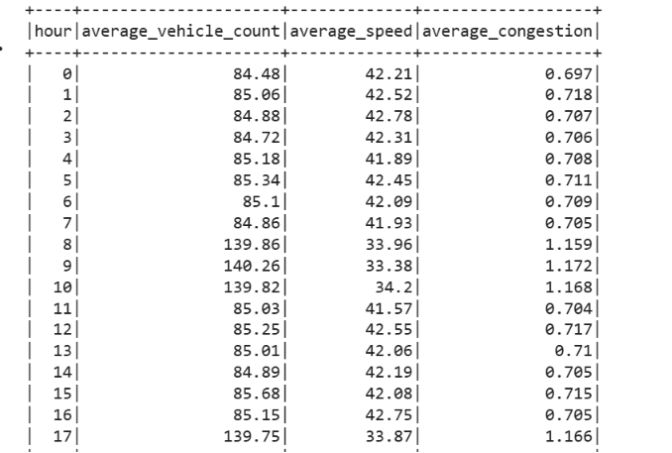

Result 4 – Congestion Analysis
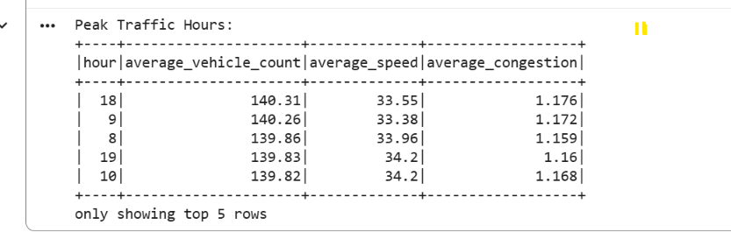
Result 5 – Clustering
K-Means clustering can classify traffic observations into groups such as:
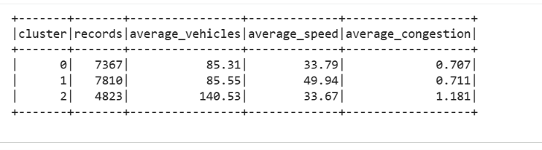
Result 6 – Graphs
Generate:
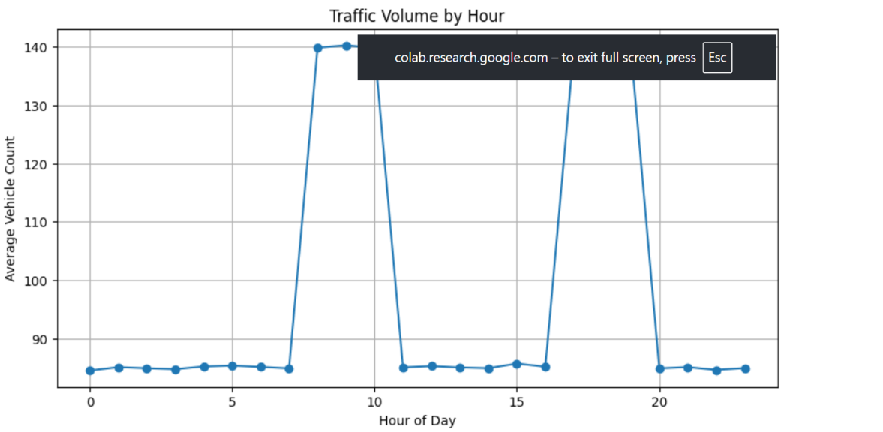
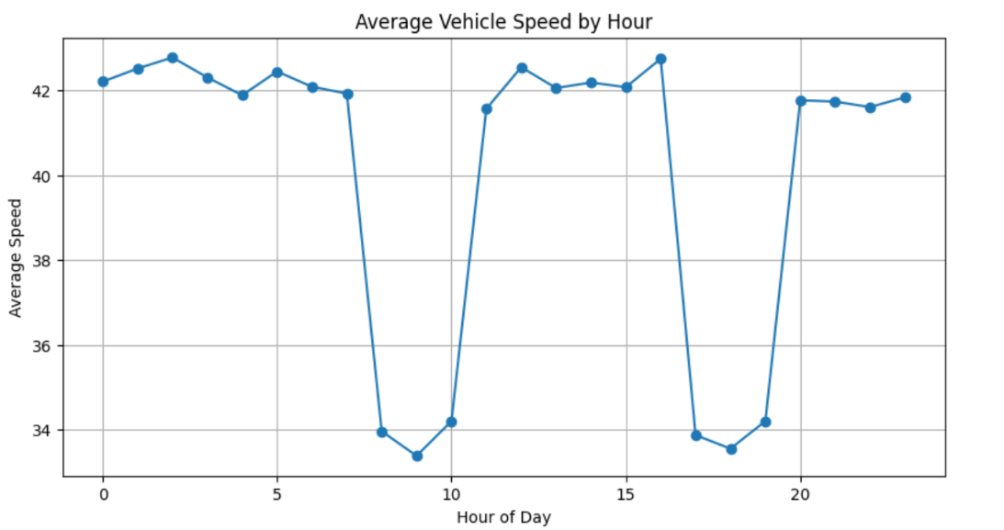
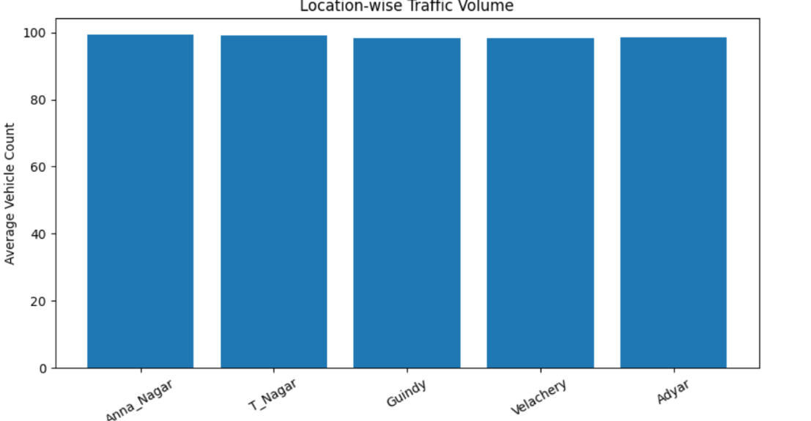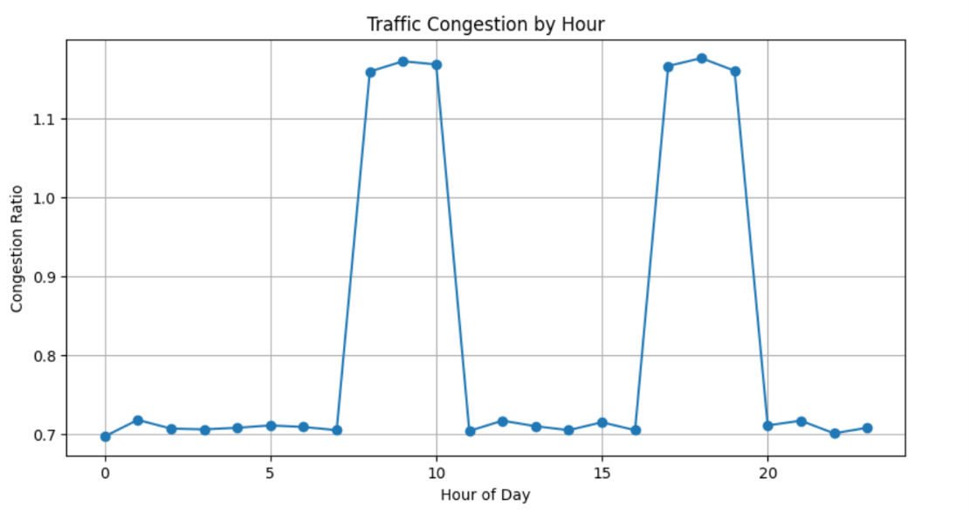
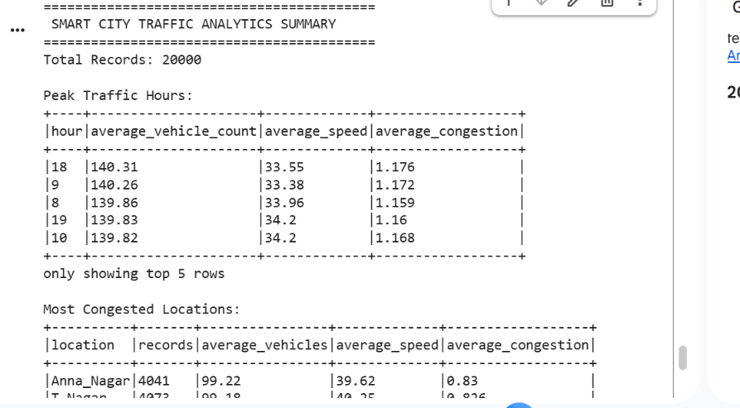

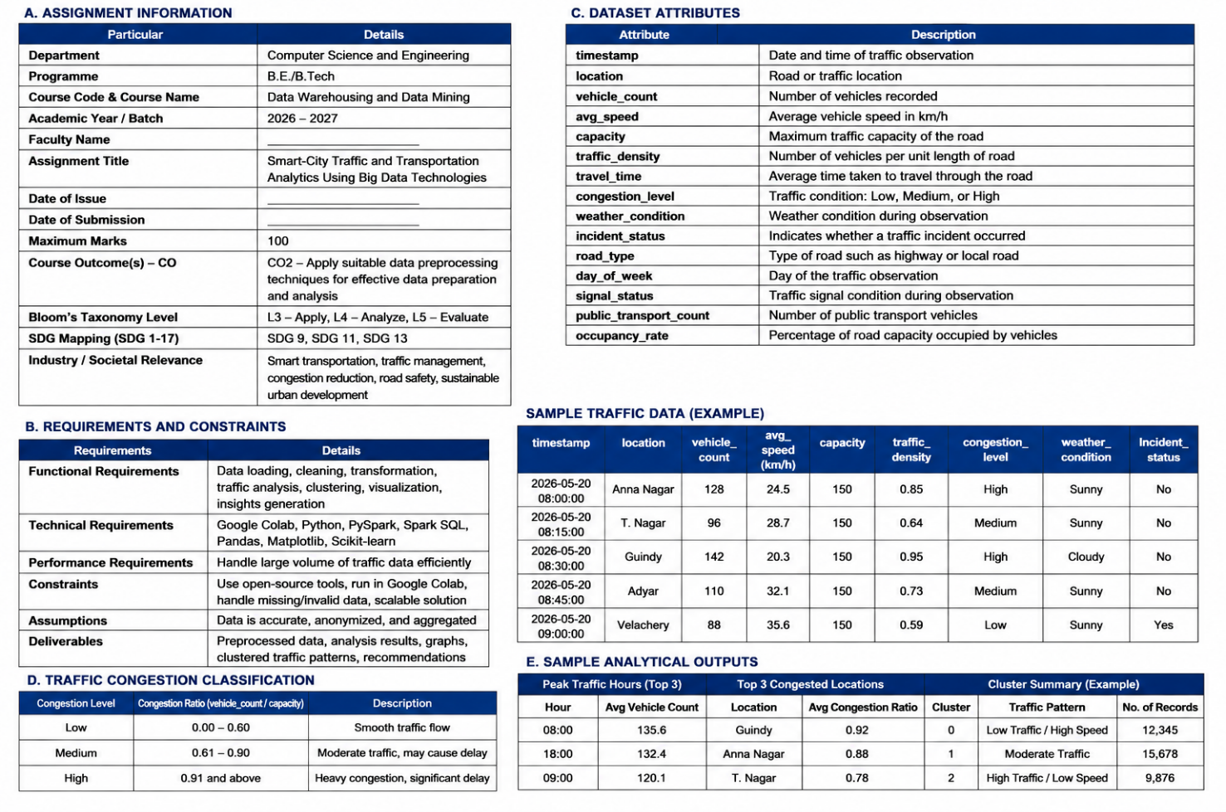

6. Analysis and Engineering Decision
The results can be analyzed to determine:
- Which hours experience maximum traffic?
- Which locations experience high congestion?
- How does traffic volume affect speed?
- Which traffic patterns occur frequently?
- How can traffic signals or public transport planning be improved?
Advantages
- Handles large traffic datasets.
- Uses distributed Big Data processing.
- Identifies peak traffic periods.
- Helps identify congested locations.
- Supports data-driven smart-city decisions.
Limitations
- Google Colab has limited computational resources.
- Synthetic data may not represent actual city traffic.
- Real-time traffic streaming is not implemented.
- Traffic predictions depend on data quality.
- Privacy must be considered when using mobility data.

7. Broader Considerations
Sustainability
Better traffic management can reduce unnecessary vehicle waiting and improve transportation efficiency.
Environment
Reducing congestion and vehicle idling can contribute to lower fuel consumption and emissions.
Society
Traffic analytics can support better transportation planning and improve urban mobility.
Safety
Traffic patterns can help authorities identify locations and periods requiring further safety investigation.
Ethics
Personal travel information should not be unnecessarily collected or exposed. Aggregated and anonymized data should be preferred.

8. Conclusion
The proposed Smart-City Traffic and Transportation Analytics Using Big Data Technologies system demonstrates how Big Data technologies can be applied to urban transportation problems. PySpark is used for scalable traffic-data processing, while data mining techniques such as K-Means clustering are used to identify traffic patterns.
The system provides useful insights into traffic volume, average speed, congestion and peak hours. The solution can be further extended with real-time streaming, traffic forecasting, anomaly detection and intelligent route optimization.

9. Student Reflection
Through this assignment, I learned how Big Data technologies can be applied to real-world transportation problems. I gained practical experience in data preprocessing, PySpark DataFrame operations, Spark SQL, traffic analytics, clustering and visualization.
If additional resources were available, the system could be improved by integrating real-time IoT traffic sensors, streaming data, larger city datasets and machine-learning-based traffic forecasting.

10. References
- Apache Spark Documentation – PySpark and Spark SQL.
- Google Colab Documentation.
- Han, J., Kamber, M., & Pei, J. Data Mining: Concepts and Techniques. Morgan Kaufmann.
- McKinney, W. Python for Data Analysis. O'Reilly Media.
- Cite the exact traffic dataset used in the implementation.
- Cite any additional research papers, datasets or AI-assisted tools used.

